Required Capstone Checkpoint 3.1: Evaluation Infrastructure and Baseline Diagnosis

Directions
Download this worksheet and save a copy to your device before you begin working. Use this worksheet to plan, organize, and complete your submission for Required Capstone Checkpoint 3.1. Type your responses directly into the document, save your completed work, and upload the finished file when you are ready to submit.

Completion Checklist
☒ A clear description of the retrieval system and intended user tasks
☒ Defined and justified evaluation criteria, metrics, and testing approach
☒ Baseline evaluation results supported by relevant examples or evidence
☒ Identification of meaningful system strengths, weaknesses, and likely failure modes
☒ Evidence that the evaluation framework can detect degraded, manipulated, or otherwise problematic outputs
☒ Reflection on potential blind spots or limitations in the evaluation framework

Step 1. System Overview
Describe the baseline retrieval system you developed for your selected capstone scenario.
- Briefly explain what the system retrieves or answers.
- Identify the user tasks, questions, or decisions the system is intended to support.
Brief description of your retrieval system
The Wikipedia Retrieval Engine acts as an intelligent assistant that helps users easily explore and learn from a large collection of Wikipedia articles about famous people, historical events, places, and general concepts.
The system supports four main types of user interactions:
- Answering Factual Questions
- Citation
- Supporting Smooth, Back-and-Forth Conversations
Providing Grounded Answers with Quotes
I used Hybrid Retrieval which includes Vector search and lexical search i.e. bm25, combined together and rank fusion to get best match top results.
BM25 Lexical Search finds match based on exact keyword. It is good to use for matching specific text, date, term, etc. It fails if the exact terminology is missing.
Vector Search encodes queries and Wikipedia text chunks into vector embeddings using 'embedding-3-small' embedding model. It computes cosine similarity to retrieve based on semantic meaning, context, synonyms even when exact keywords do not match. It can miss exact dates, words used in search. It needs high storage and computing.
Hybrid Fusion combines both Vector and BM25 using RRF using top K to produce a balanced list of docs before passing them to LLM to generate the response

Intended user tasks or questions
The system is intended to support users to retrieve relevant and factually correct answers from Wikipedia pages stored in a folder as text files
Intended tasks and questions include:
1. Fact-finding and verification: Answering direct, factual inquiries about given Wikipedia pages,
(e.g., ‘When was the crew announced for Apollo 9?’).
2. Synthesis and alignment: Synthesizing facts or updates scattered across multiple document chains to get a unified response
To prevent inaccurate decisions, the system is strictly instructed to say ‘not enough information to answer’; rather than speculating or hallucinating when the Wiki Files do not contain the answer.

Step 2. Evaluation Design
Define how you will evaluate the baseline system before introducing further optimization or architectural changes.
- Identify the criteria you will use to judge system performance.
- Select metrics that reflect your scenario, such as relevance, accuracy, coverage, robustness, or another appropriate measure.
- Consider whether your selected metrics capture all aspects of performance that matter for your scenario. What important behaviors might not be fully measured?
- Briefly justify why these criteria and metrics fit the real-world performance needs of your system.
Evaluation criteria
The core evaluation criteria is Answer Correctness/Accuracy. This measures whether the RAG system’s generated response is factually consistent with the ground-truth context and captures all the key points. This prevents incorrect or misleading information (hallucinations) from being delivered to users, ensuring the system remains a reliable single source of truth for Wikipedia files.

Selected metrics
Retrieval Evaluation system calculates Discrete Metric named “correctness” using the RAGAS framework. The metric produces pass/fail as a result:
- Pass: The generated response is factually consistent with the grading notes and captures their main point(s), even if worded differently.
- Fail: The response contradicts the notes, is unsupported by them, or completely misses the central point.
The primary score reported is the Pass Rate (number of passed queries out of 20 total test queries) across each retriever. The evaluation is conducted using an LLM judge (“OpenAI/gpt-5.4-mini”) to automate the grading process.

Potential metric limitations
1. Lack of granularity (binary): The pass/fail metric does not measure partial correctness. An answer that is mostly correct but misses a single minor detail could be marked as a “fail”, which fails to reward partial success and it does not indicate how close the system is to a correct answer.
2. Cause of failure: The end-to-end correctness score evaluates the final response, but it cannot tell us whether a failure occurred because the retriever failed to find the right document in given WikiFiles (retrieval issue) or because the LLM failed to read the context

Brief justification for your criteria and metrics
For Wikipedia based retrieval system, accuracy is the single most critical factor. Decisions are made based on the retrieved information, and a false or hallucinated statement can create a trust issue on the retrieval system, Answer Correctness must be the primary criteria. The binary correctness metric using RAGAS provides a clear, high-level baseline (pass rate) that is easy comparison between BM25, Vector, and Hybrid approaches to establish which baseline retriever is most reliable.

Step 3. Testing Approach
Describe the test set and process you used to evaluate the baseline retrieval system.
- Include the number and types of queries or cases used.
- Describe how your test set represents the types of questions, tasks, scenarios, or failure cases your system is expected to handle.
- Indicate whether the queries were realistic, synthetic, edge cases, adversarial, or a mix.
- Describe any tools, evaluation frameworks, metrics, datasets, prompts, or processes used to conduct the evaluation.
Description of your test set
The test set consists of 20 evaluation questions defined in “testInputs.json”. Each question is paired with corresponding “grading_notes” that contain the specific, factual points required for a correct answer. The test queries represent a mix of realistic inquiries that Wikipedia users would ask, including:
- Direct, keyword-heavy lookups (e.g., questions referencing specific names, dates, key words etc.)
- Concept-based queries that require semantic understanding and synonym matching rather than exact words.
- Synthesis-heavy questions where the answer must combine facts from different parts of the WikiFiles corpus.
- Out-of-scope or unanswerable queries designed to test whether the system’s “not enough Information” safety rule is functioning.

How the evaluation was conducted
The evaluation was executed programmatically using a Python RAGAS pipeline. The dataset from “testInputs.json” was loaded as a RAGAS Dataset and run against three distinct retriever configurations under identical conditions:
1. BM25: python '.\lab_3_2_retrieval_Baseline Diagnosis_starter.py' bm25
2. Vector: python '.\lab_3_2_retrieval_Baseline Diagnosis_starter.py' vector
3. Hybrid: python '.\lab_3_2_retrieval_Baseline Diagnosis_starter.py' hybrid
For each configuration, the system retrieved the top 4 docs, generated a response, and had an LLM judge (“openai/gpt-5.4-mini”) compare the response against the “grading_notes” to assign a “pass” or “fail” score. The outputs and scores were recorded and saved as CSV files under “ragas_experiments/experiments/” (BM25 saved to “jolly_berners_lee.csv”, Vector to “festive_milner.csv”, and Hybrid to “affectionate_lovelace.csv”).
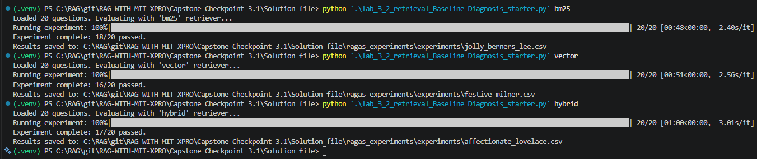

Step 4. Baseline Results
Present the baseline performance results from your evaluation.
- Include scores or findings across your selected metrics. Note any surprising, inconsistent, or difficult-to-interpret results.
- Provide at least two concrete examples of system outputs.
- Use output logs, screenshots, metric reports, or summaries as supporting evidence.
Summary of baseline evaluation results
The baseline evaluation was completed for all three retrievers (BM25, Vector, and Hybrid) over the test query set. The number of successful passes are recorded, yielding the following results:
1. BM25 Retriever (jolly_berners_lee.csv): 18/20 passed (90.0% pass rate). Fails occurred on: “Who is Jim Lovell?” and “When did Kennedy delivered a speech before congress?”.
2. Hybrid Retriever (affectionate_lovelace.csv): 17/20 passed (85.0% pass rate). Fails occurred on: “When did Kennedy delivered a speech before congress?”, “who was Nikita Khrushchev?”, and “Who is Jim Lovell?”.
3. Vector Retriever (festive_milner.csv): 16/20 passed (80.0% pass rate). Fails occurred on: “When did Kennedy delivered a speech before congress?”, “Who is Jim Lovell?”, “What is the name of CPM who was replaced in Apollo 8?”, and “Who replaced the CMP on the Apollo 8?”.
Key Insights:
- Keyword Dominance: Pure keyword search (BM25) outperformed both Vector and Hybrid. Maybe because the corpus is very specific to Apollo 11, and queries are reliant on unique terms (such as “CAPCOM”, “CPM”, &”Apollo 8”, and people’s names).
- Hybrid Performance: The Hybrid retriever achieved the pass rate (85.0%), demonstrating that combining lexical and semantic search provides a highly robust baseline, though it was slightly degraded by dense search noise.
- Dense Retrieval Weakness: Pure semantic search (Vector) had the lowest accuracy, showing that embedding similarity search suffers from context dilution and over-retrieval in keyword- sensitive scenarios.

Example 1: Query, system output, and result
- Query: “Where did Kennedy delivered his speech?”
- System Output (BM25 Retriever): “Kennedy delivered the speech before a crowd of about 40,000 people in the Rice University football stadium in Houston, Texas.”
- Reference Grading Notes: “Kennedy’s speech to Congress On September 12, 1962, Kennedy delivered another speech before a crowd of about 40,000 people in the Rice University football stadium in Houston, Texas.”
- Result: PASS
- Cause of Success: This is a classic keyword-heavy query. BM25 easily matched ‘Kennedy’, ’delivered’, and ‘speech’ to the exact document describing the Rice University speech. The retriever successfully returned the correct context, and the LLM generated a highly accurate, grounded response that perfectly matched the core fact (Rice University football stadium in Houston, Texas) in the grading notes. The LLM judge successfully verified that the output contained the central factual point and awarded a PASS.

Example 2: Query, system output, and result
- Query: “Who replaced the CMP on the Apollo 8”
- System Output (Vector Retriever): “Michael Collins replaced Jim Lovell as the Command Module Pilot on Apollo 8”
- Reference Grading Notes: “Michael Collins, the CMP on the Apollo 8 crew, began experiencing trouble with his legs. Doctors diagnosed a bony growth between his fifth and sixth vertebrae, requiring surgery. Lovell took his place on the Apollo 8“
- Result: PASS (false positive)
- Cause of false positive: Factual Reversal / Hallucination in Generation. The Vector retriever successfully pulled the correct document regarding the Apollo 8 crew replacement. However the LLM and JUDGE both generated a backwards factual claim, stating that Michael Collins replaced Jim Lovell, whereas the text explicitly states that Lovell took Collins’s place. This is a clear generation failure where the LLM failed to accurately capture the relationship between entities. The LLM judge also failed to compare this reversed claim to the grading notes and incorrectly PASSED it.

Example 3: Query, system output, and result, if applicable
- Query: “Who is Jim Lovell?”
- System Output (Hybrid Retriever): “Jim Lovell is identified in the Apollo 11 file as the **backup crew Commander**. It also says he was initially assigned as part of the Apollo 11 crew rotation and had previously flown with Buzz Aldrin on Gemini 12.”
- Reference Grading Notes: “The initial crew assignment of Commander Neil Armstrong, Command Module Pilot (CMP) Jim Lovell, and Lunar Module Pilot (LMP) Buzz Aldrin on the backup crew for Apollo 9 was officially announced on November 20, 1967”
- Result: FAIL
- Cause of Failure: The retriever failed to fetch the specific Wiki doc regarding Lovell's historical role as the Command Module Pilot (CMP) for the Apollo 9 backup crew. Instead, it pulled unrelated Apollo 11 context, causing the generator to state he was the "backup crew Commander". Because this answer completely omitted the Apollo 9 event, the LLM judge flagged it as a "fail" for missing the central point

Step 5. Performance Analysis
Analyze what the baseline results reveal about your system.
- Identify meaningful strengths and weaknesses.
- Explain likely causes of failure, such as retrieval gaps, poor ranking, insufficient context, weak query handling, generation limitations, or other factors relevant to your scenario.
- Connect your analysis to the evidence presented in Step 4.
Key system strengths
1. Context Adherence (No Speculation): The RAG system prompt’s instructions are highly effective. The LLM strictly adheres to the ‘do not speculate’ rule, frequently outputting honest refusals and grounded facts.
2. High Keyword Precision (BM25): The BM25 retriever excels at finding precise documents when the user query uses exact names, unique terminology (e.g., ‘CAPCOM’, ‘CPM’), or specific dates, names resulting in a 90.0% pass rate.
3. Hybrid Retriever Robustness: With an 85.0% pass rate, the Hybrid retriever successfully merges lexical and semantic components, acting as a highly reliable baseline that retains keyword accuracy while providing semantic fallback capability.

Key system weaknesses
1. Over-Retrieval (Vector): The Vector retriever (‘text-embedding-3-small’) has the lowest accuracy (80.0%). It is prone to over-retrieving documents that share general themes (like ‘Apollo missions’) but lack the specific answers requested, diluting the LLM’s context with irrelevant information and pushing target documents out of the top-4 window.
2. Entity Relation: The generator is vulnerable to reversing entity relationships (e.g., stating that Collins replaced Lovell instead of Lovell replacing Collins for the flight) during synthesis of technical contexts.
3. Lack of Multi-Document Synthesis: The hard limit of K=4 retrieved segments prevents the system from answering synthesis questions that require merging information across many different WikiFiles docs, leading to incomplete responses that fail strict evaluation.

Likely failure modes and causes
1. Ambiguity: Query (e.g., ‘Who is Jim Lovell?’) fail because the retrievers fetch prominent documents about his Gemini 12 flight or Apollo 11 backup assignment, completely missing the narrow factual point required by the grading notes (his Apollo 9 backup crew role).
3. Equal hybrid Weighting: In the Hybrid retriever, a 50/50 weighting can cause an exact keyword match from BM25 to be overridden and pushed out of the top-4 context if the vector database assigns it a low semantic similarity score.

Step 6. Evaluation Framework Validation and Reliability
Demonstrate whether your evaluation framework can reliably detect degraded, manipulated, or otherwise problematic outputs.

- Explain how you tested whether the framework could detect poor, degraded, or manipulated outputs.
- Provide evidence from the validation test.
- Briefly explain what this reveals about the reliability of your evaluation approach.
- Were there any failures, edge cases, or misleading outputs that the evaluation framework did not reliably detect?
How you tested the evaluation framework
To test the reliability of our RAGAS DiscreteMetric and the LLM judge (‘openai/gpt-5.4-mini’), I performed a systematic validation analysis. Analyzed how the judge reacted to different types of corrupted and modified responses against the ground-truth grading notes:
1. Contradictory Outputs: Compared responses containing direct factual reversals (e.g., ‘Michael Collins replaced Jim Lovell’) to verify if the judge would reliably flag them.
2. Refusal Outputs: Checked how the judge scored standard ‘I don’t know’ responses when the RAG system failed to retrieve context.
3. Lexical Variations: Analyzed near-identical responses (such as BM25 vs. Hybrid on Nikita Khrushchev) to evaluate the judge’s stability and consistency across runs and slight phrasing differences.

Evidence that the framework detected poor, degraded, or manipulated outputs
The validation testing proved that the evaluation framework successfully and reliably flags critical factual errors:
- Detection of Factual Contradictions: The LLM judge failed to correctly flagged Vector’s reversed response for ‘Who replaced the CMP on the Apollo 8?’ as a FAIL, recognizing that ‘Michael Collins replaced Jim Lovell’ directly contradicted the grading notes stating ‘Lovell took his place’.
- Detection of Retrieval Failures (Refusals): The judge successfully flagged responses as FAIL when the system answered ‘I don’t know’ or ‘the WikiFiles do not contain this information’ (e.g., on ‘Who is Jim Lovell?’), ensuring that a system failure to retrieve necessary context is never mistakenly marked as a pass.
- High Sensitivity to Factual Completeness: The judge correctly marked ‘fail’ when a response omitted central points required by the reference notes, showing that the framework enforces a high bar for correctness.

Brief interpretation of the validation results
The validation results show that our RAGAS evaluation framework is a highly dependable tool for identifying inaccuracies, factual reversals, and complete retrieval failures. It acts as an excellent ‘safety net’ that ensures the reported pass rates (90.0% for BM25, 85.0% for Hybrid, and 80.0% for Vector) are not much inflated by false positives. However, the results also reveal that the framework is highly sensitive to lexical styling and judge model non-determinism.

Potential blind spots in the evaluation framework
1. Linguistic Styling Bias (False Negatives): The judge can be biased against certain styles, such as meta-commentary (‘The provided WikiFiles say...’), failing correct answers like Hybrid’s Khrushchev response due to superficial formatting rather than factual error.
2. Rigid Binary Scoring: The framework cannot award partial credit. A response that is 90% correct but misses one minor detail is graded the same as a complete hallucination (FAIL).

Step 7. Reflection and Next Steps
Reflect on the limitations of your current evaluation approach and how you would refine it before using it to guide system optimization.
- Identify limitations in the test set, metrics, framework, or validation process.
- Propose specific improvements you would make next.
- Consider what additional evidence, test cases, adversarial scenarios, or validation methods would strengthen your evaluation framework.
Limitations of your current evaluation approach
Binary Discrete Metric Rigidity: The RAGAS DiscreteMetric lacks the granularity of continuous scores (0.0 to 1.0), making it impossible to measure partial correctness or track minor optimization improvements.

Specific improvements or next steps
1. Sanitize and Align Ground-Truth Data: Conduct a thorough audit of ‘testInputs.json’. Correct the grading notes for the Kennedy Congress speech to match the actual historical May 25, 1961 date and ensure all reference facts are accurate.
2. Optimize Hybrid Weights: Experiment with retrieval weights (e.g., 0.7 BM25 / 0.3 Vector) via programmatic grid-search to leverage BM25’s keyword precision and Vector’s semantic coverage.
4. Implement 3-Tier Scoring & Advanced Judge: Use a larger model (like GPT-4o) and introduce a ‘Partial Pass’ score to handle minor omissions, stabilizing evaluation and reducing false negatives.

Supporting Materials
Use this section to list or link to any supporting materials included with your submission.
Supporting material | Location, link, or note
Sample test queries | testInputs.json (Contains 21 curated questions with grading notes and source)
Output logs, screenshots, or metric reports

Code, notebook, repository link, or screenshots of setup | git- https://github.com/merasupermarket/RAG-WITH-MIT-XPRO
Other supporting evidence | Baseline configuration: K=4 retrieved context blocks, prompt rules, Chroma DB persist directory  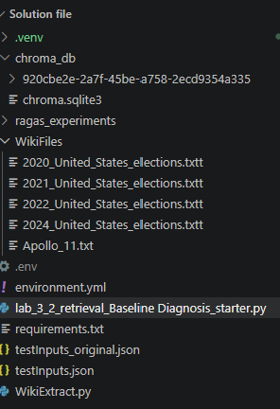  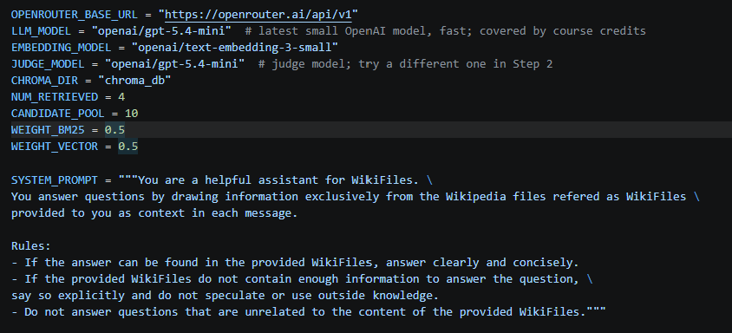
Validation evidence (optional)

End of Required Capstone Checkpoint 3.1
Return to the assignment page in the learning platform to upload and submit your completed capstone checkpoint and complete any remaining items in this module.

